**Mobile Automation Documentation**

**What is Mobile Automation: -**

Mobile automation means using specialized tools and software to make mobile app development and testing easier. It involves automating tasks like testing the app on different devices, checking if it works correctly, and even deploying the app to app stores. This helps save time, reduce errors, and make sure the app works well on various phones and tablets.

**Why Mobile** **Automation:-**

Mobile applications have become an integral part of our daily lives, and their usage continues to grow exponentially. To meet the demands of users, it's crucial to ensure that mobile apps are of high quality, free from defects, and deliver a seamless user experience. Mobile automation testing plays a vital role in achieving these goals, and this documentation outlines the reasons why it's essential.

* Mobile devices come in various sizes, operating systems (iOS, Android), and configurations. Testing on all possible combinations manually is time-consuming and impractical.
* Mobile automation allows us to test on a wide range of devices and configurations simultaneously, ensuring our app works on all target platforms.

**Types** **of Applications:-**

* **Web** **applications:-** It runs in web browsers and are accessible from any device with a browser.

Examples:- Web-mail,Online calculator etc.

* **Native applications:-**These are platform-specific, installed on the device, and offer high performance.
* Examples:-Calender,Calculator,Camera etc.
* **Hybrid applications:-** blend native and web elements to achieve cross-platform compatibility while maintaining some native features.

Examples:- whatsapp,Instagram,Netflix etc.

**Which automation tools are used for mobile testing?**

* [1. Appium](https://www.browserstack.com/guide/mobile-application-testing-frameworks#toc1)
* [2. NightwatchJS](https://www.browserstack.com/guide/mobile-application-testing-frameworks#toc2)
* [3. Calabash](https://www.browserstack.com/guide/mobile-application-testing-frameworks#toc3)
* [4. XCUITest](https://www.browserstack.com/guide/mobile-application-testing-frameworks#toc4)
* [5. EarlGrey](https://www.browserstack.com/guide/mobile-application-testing-frameworks#toc5)
* [6. Selendroid](https://www.browserstack.com/guide/mobile-application-testing-frameworks#toc6)
* [7. Espresso](https://www.browserstack.com/guide/mobile-application-testing-frameworks#toc7)
* [8. Robotium](https://www.browserstack.com/guide/mobile-application-testing-frameworks#toc8)

**Which framework is best for mobile app automation?**

The choice of mobile app testing framework depends on the platform of the application (Android, iOS, or both), the programming language used for development, the type of testing required (functional, regression, performance, etc.), and the overall skill set of the testing team. Hence, the best framework is the one which fits your project needs.

**Appium:-**

1. Appium is an open-source framework used for automated mobile applications designed to facilitate UI automation of many app platforms, including mobile (iOS, Android, Tizen), browser (Chrome, Firefox, Safari), desktop (macOS, Windows), TV (Roku, tvOS, Android TV, Samsung),
2. It can automate web,native and hybrid mobile applications.
3. It runs the test cases using the WebDriver interface.
4. Appium allows QAs to create test scripts in multiple programming languages – Java, JavaScript, PHP, Ruby, Python, and C#.

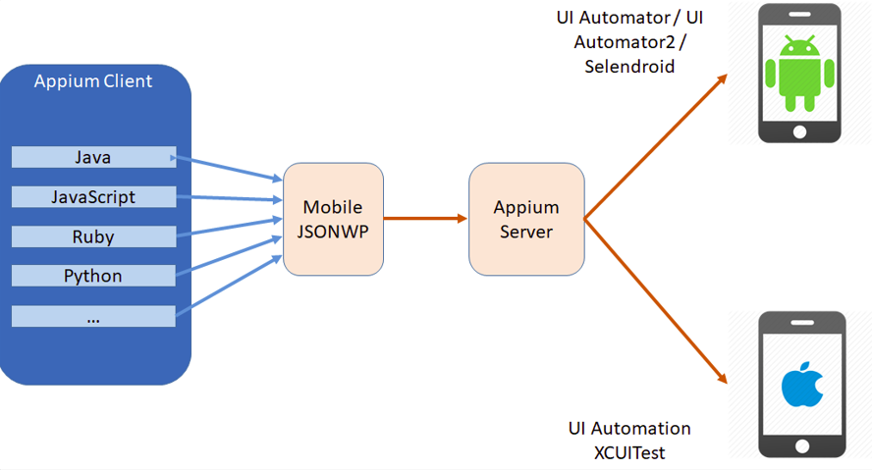

**Prerequisite for Mobile Automation:-**

**Java**

**Node and npm**

**Installation for Mobile Automation using Appium:-**

* **install JDK on your system**

1.Download Java for Windows.

Java JDK download link : <https://www.oracle.com/in/java/technologies/javase/jdk11-archive-downloads.html>

2. Run the Java installer.

3.Set the JAVA_HOME upto jdk and set PATH variable upto bin folder in environment variables settings.

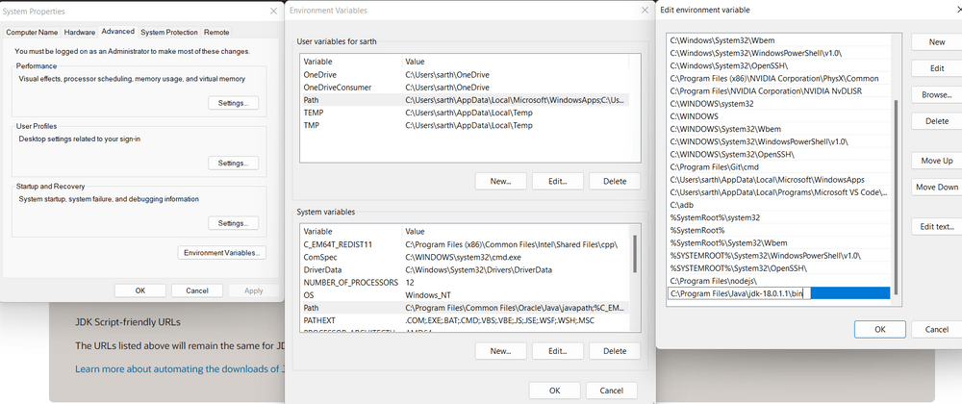

1. Run a JDK command to verify Java install was a success.

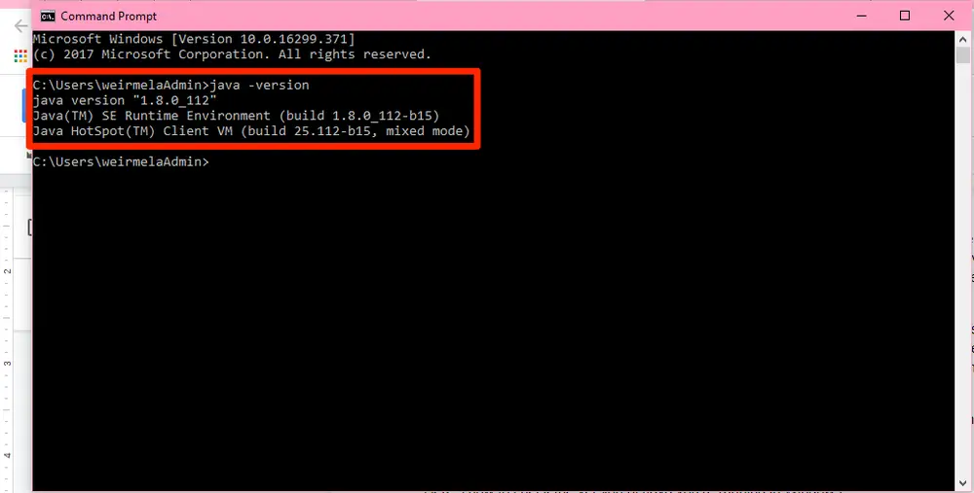

* ⦁ **Node.js and npm Installation:**

1. Make sure you have Node.js and npm (Node Package Manager) installed on your system. You can download and install them from the official Node.js website: <https://nodejs.org/en/download/current>
2. Verify node and npm installed successfully.

**node –v and npm -v**

1. 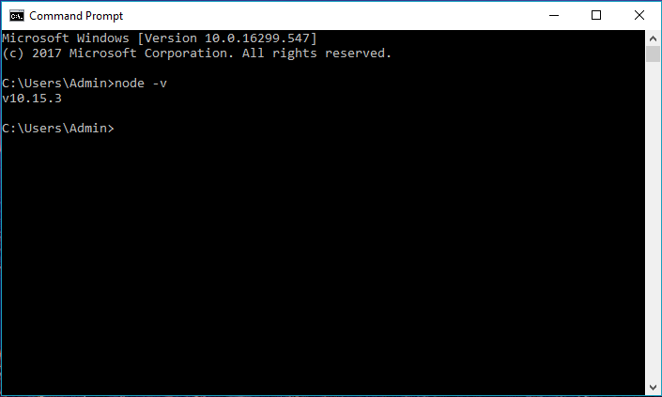

* **Android Studio Installation**: Visit the official Android Studio website to download the installer for your operating system <https://developer.android.com/studio> and click on the Download Android Studio Giraffe

Android Studio download : <https://developer.android.com/studio>

1. After installing Android studio go to More Actions,click on SDK Manager check any Android platform click on ok and confirm.
2. Then copy Android Sdk path ,set it as ANDROID_HOME in environment settings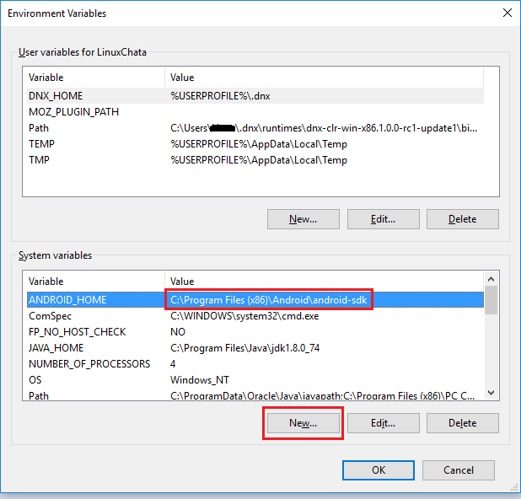
3. Then go to file explorer open program files then open android sdk navigate upto platform tools and copy path and set it as PATH in environment settings**.**

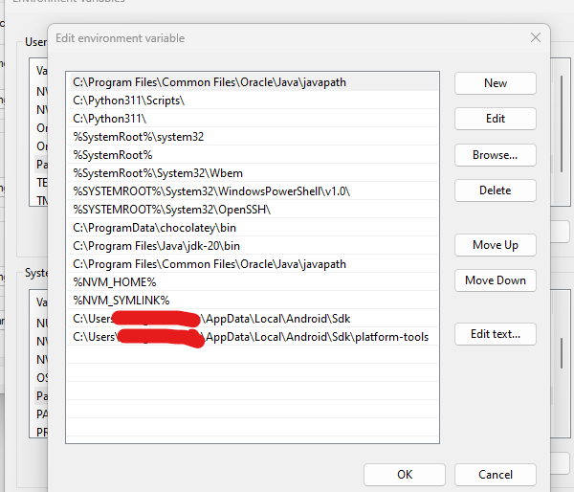

* Appium Installation:-

1.Appium GUI

2.Appium CLI

1.Appium GUI:-Download and install Appium Desktop app.

* Appium Desktop app link : <https://github.com/appium/appium-desktop/releases>
* Download the below highlighted link for Appium GUI(Desktop App).

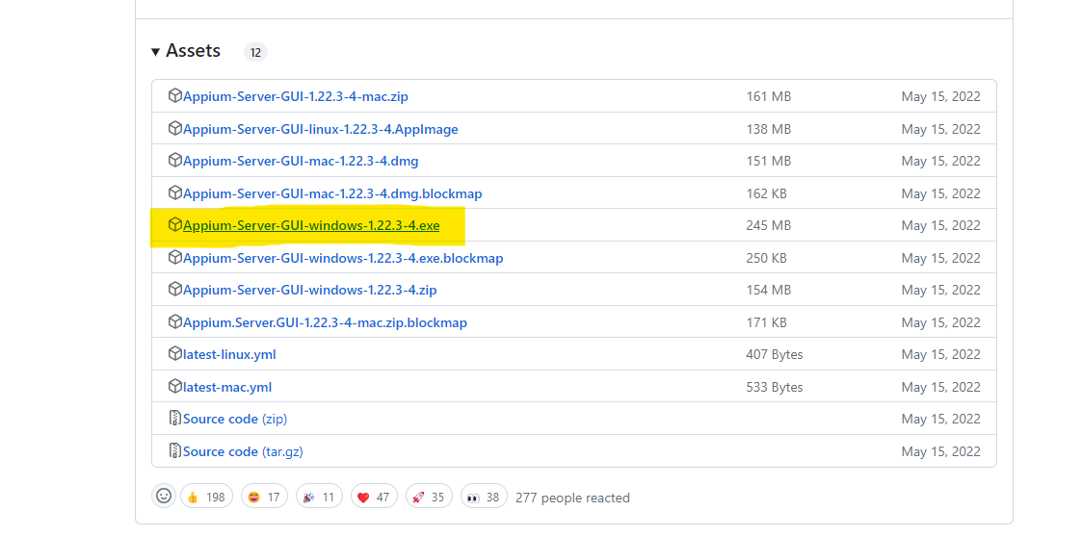

2.Appium CLI:-

1.open command-prompt,enter the below command.It will install appium server globally.

**npm i --location=global appium**

Install appium server locally

Appium node service :-**npm i appium**

To verify appium server is installed or not using below command.

**appium –v**

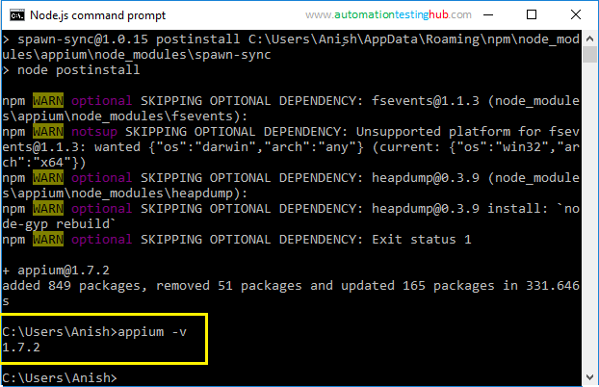

To run appium server through command-prompt use below command.

**appium**

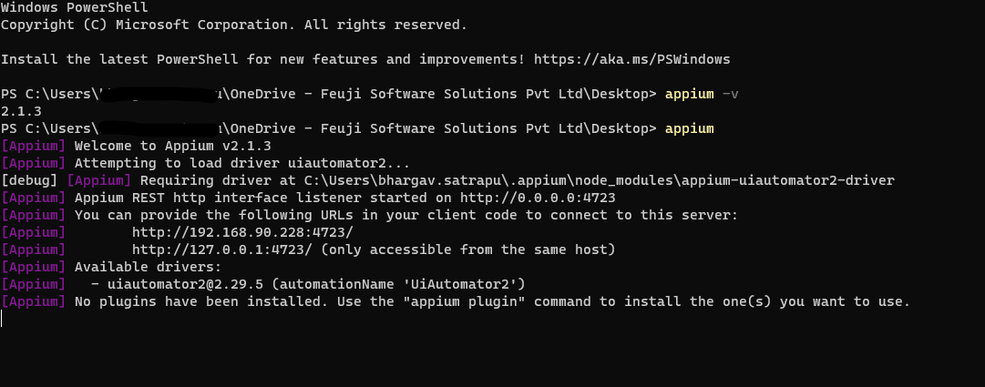

* **Appium Driver Installation:-**

We can install appium driver in Android and Ios devices.

1. **Android appium driver installation:-**

* To install appium driver in android device type the below command in command-prompt.

**appium driver install uiautomator2**

**2. IOS appium driver installation:-**

* To install appium driver in ios device type the below command in command-prompt.

**appium driver install xcuitest**

* To know the installed appium drivers type the below command in command-prompt.

**appium driver list --installed**

* **Appium inspector app installation:-**
* To download and install appium inspector app click on the below link.

<https://github.com/appium/appium-inspector/releases>

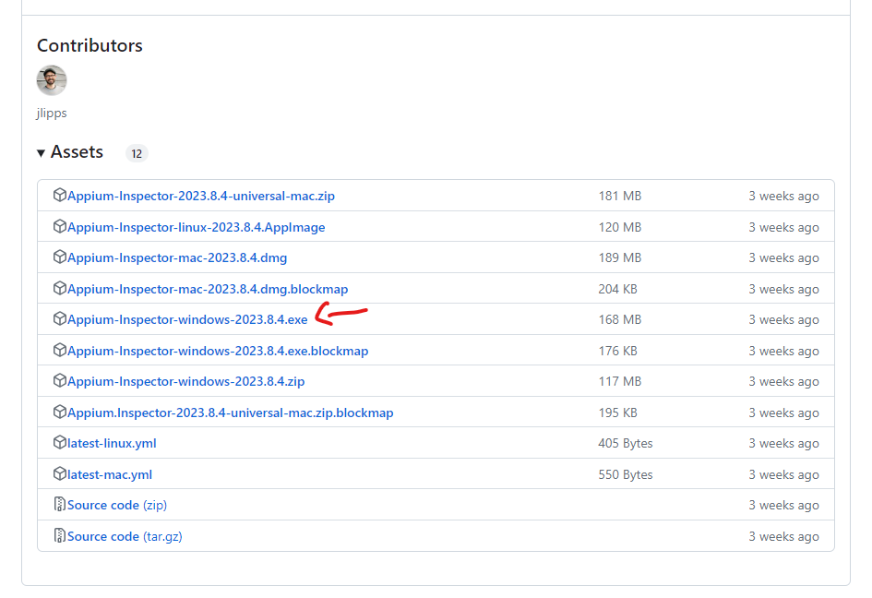

click on [Appium-Inspector-windows-2023.8.4.exe](https://github.com/appium/appium-inspector/releases/download/v2023.8.4/Appium-Inspector-windows-2023.8.4.exe)

* **Appium Capabilities List:-**

Appium GitHub link : <https://github.com/appium/appium>

Appium inspector app : <https://github.com/appium/appium-inspector/releases>

Appium capabilities list : <https://appium.io/docs/en/2.0/guides/caps/>

ApkInfo app apk download : <https://www.apkmonk.com/app/com.wt.apkinfo/>

Ajio app apk download : <https://www.apkmonk.com/app/com.ril.ajio/>